LABSHEET-02
Program List
1. Load a dataset and identify missing values in each column.
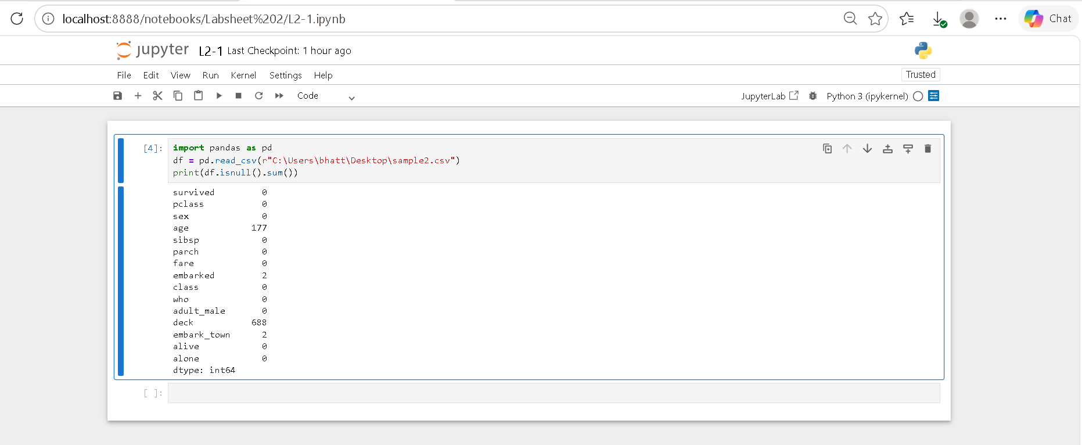
2. Display the percentage of missing values in every feature.
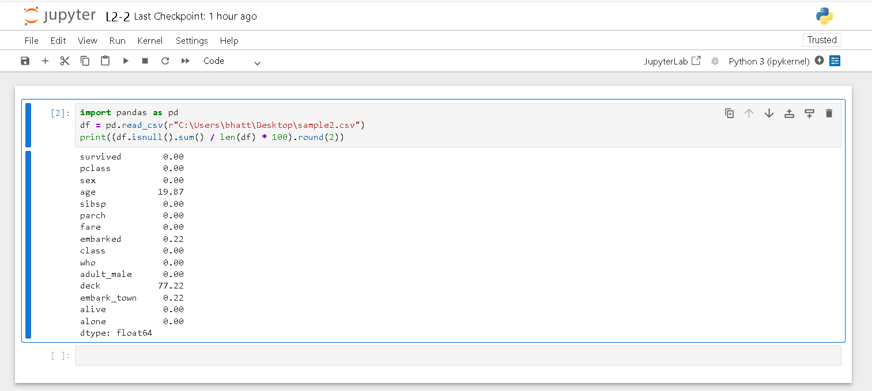

3. Remove rows containing missing values from the dataset.
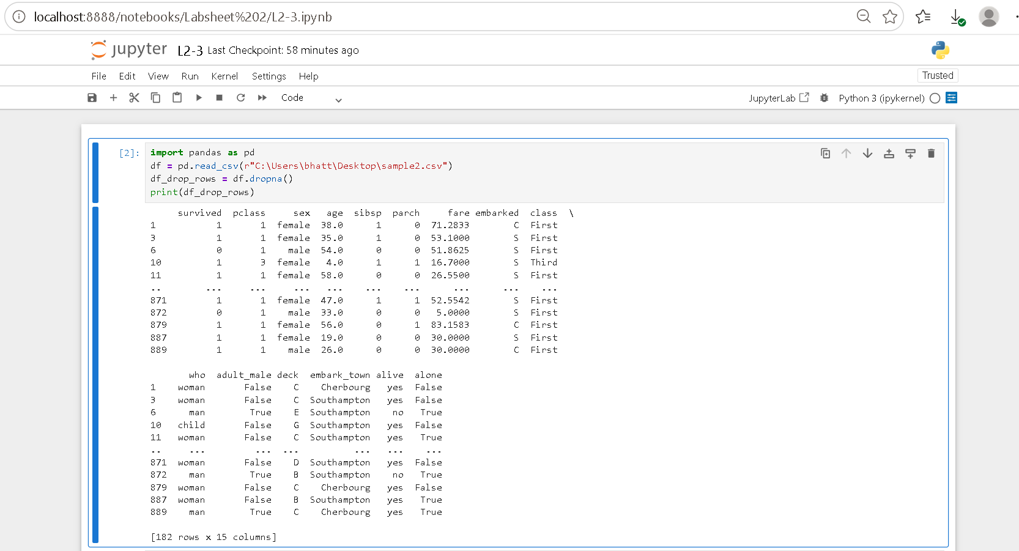
4. Remove columns having more than 50% missing values.
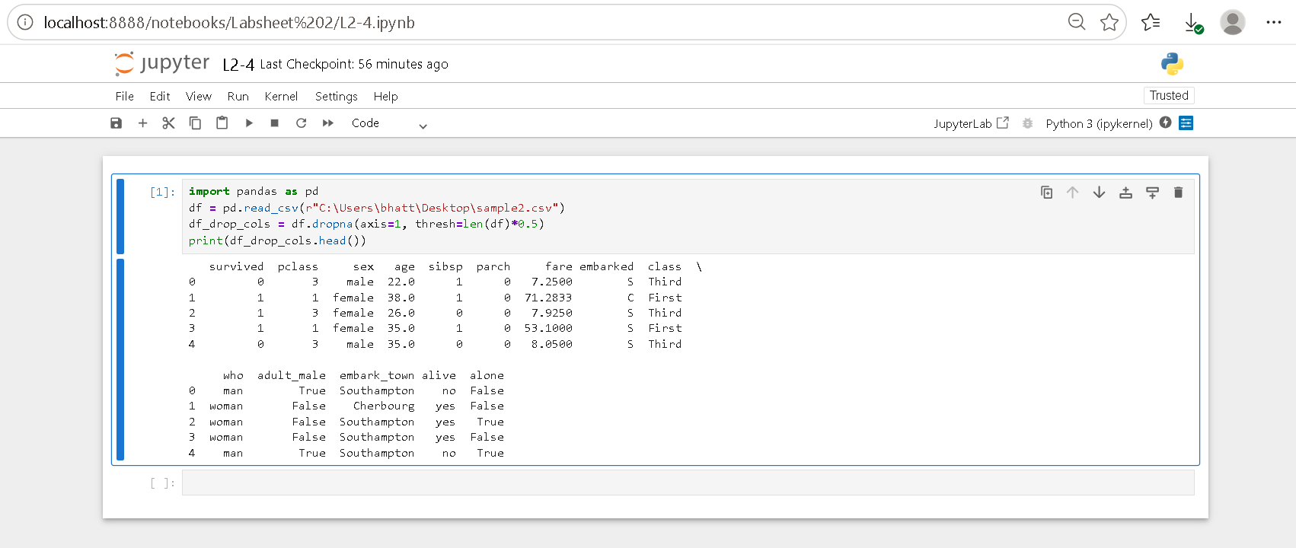
5. Replace missing numerical values using the mean.
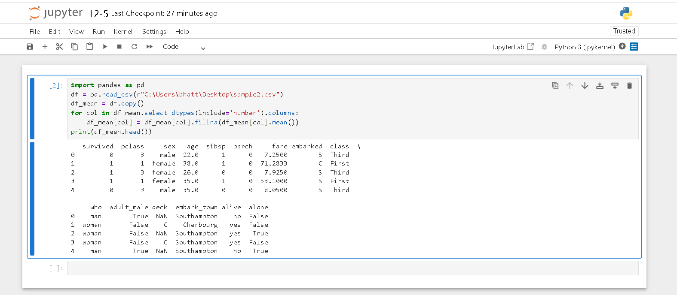
6. Replace missing numerical values using the median.
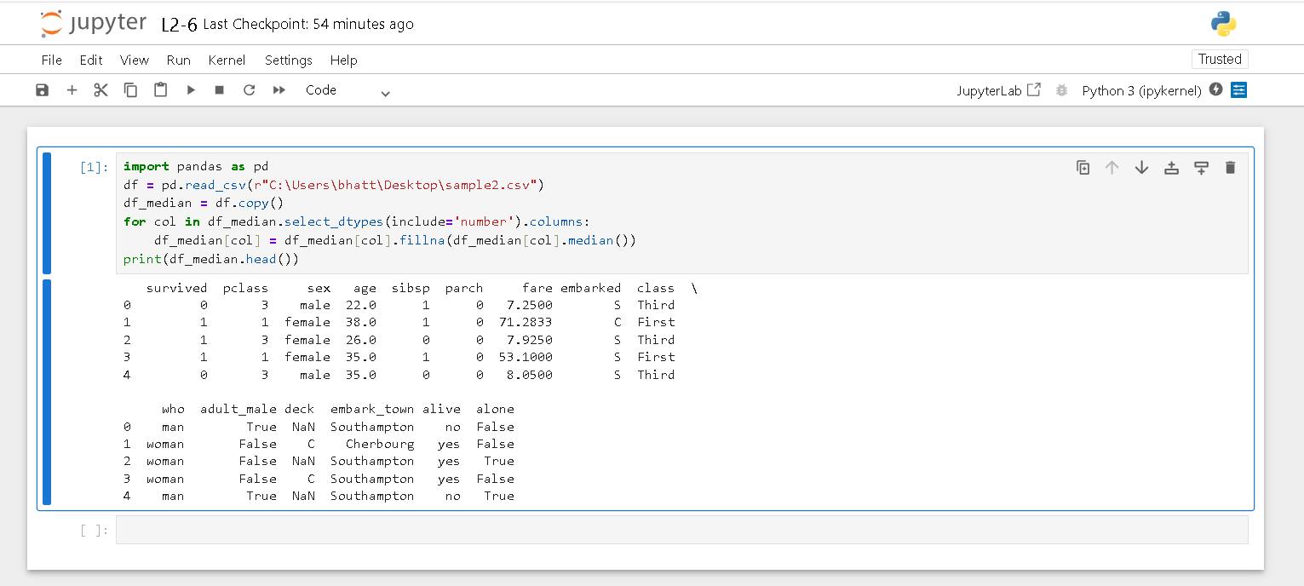
7. Replace missing categorical values using the mode.
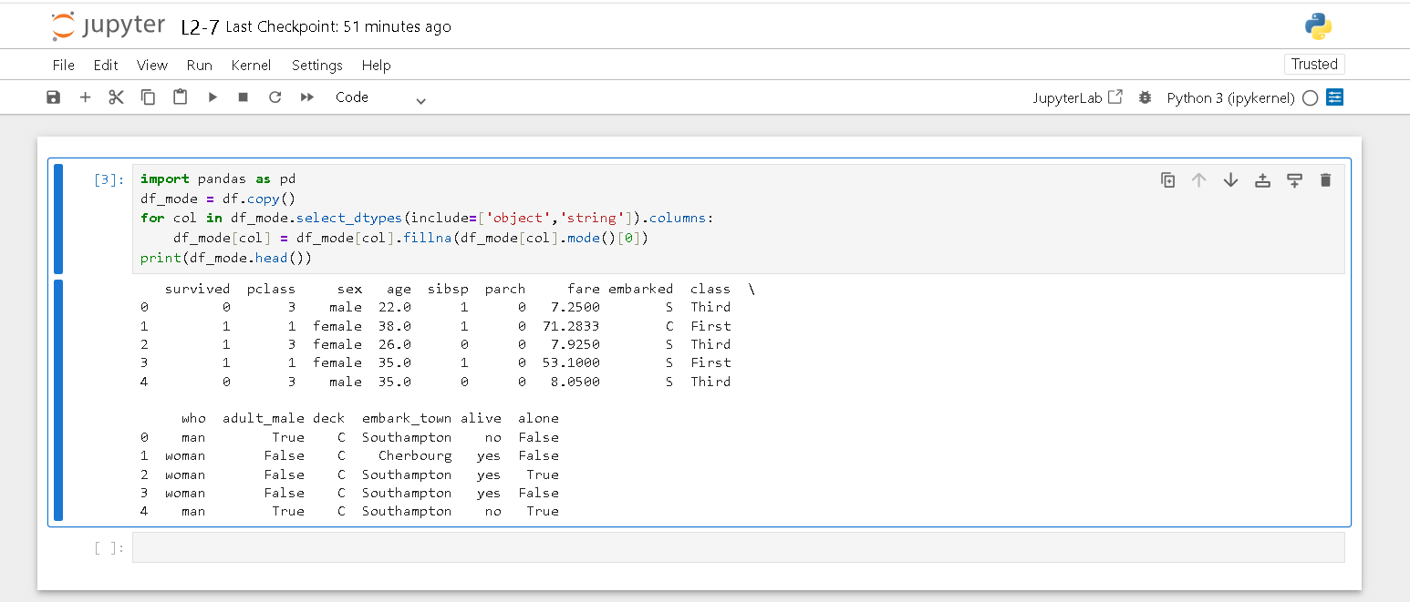
8. Fill missing values using forward fill (Forward Propagation).
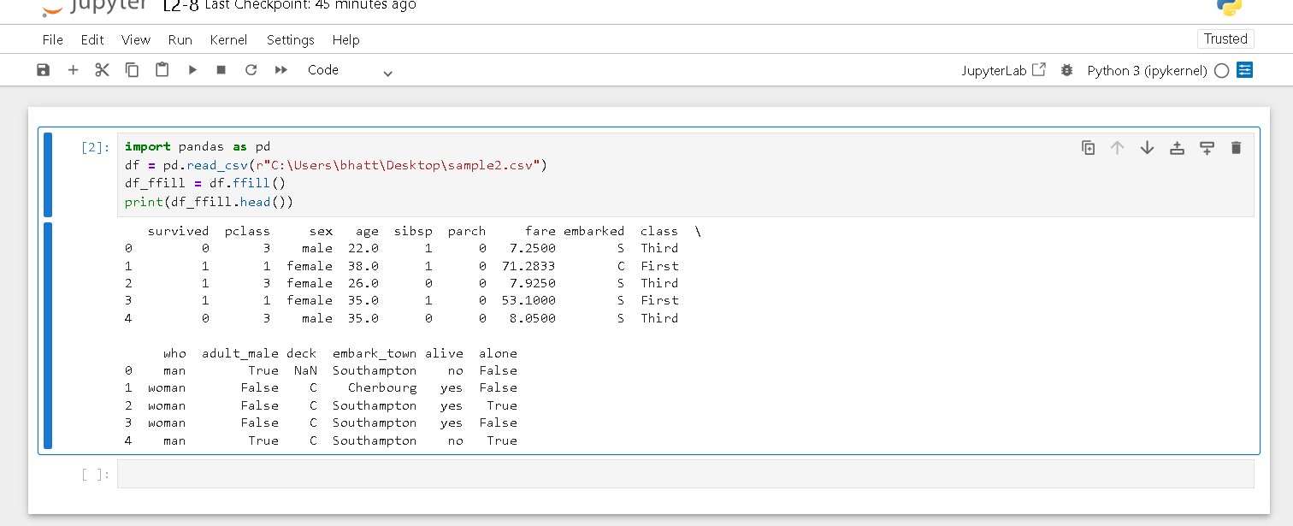
9. Fill missing values using backward fill (Backward Propagation).
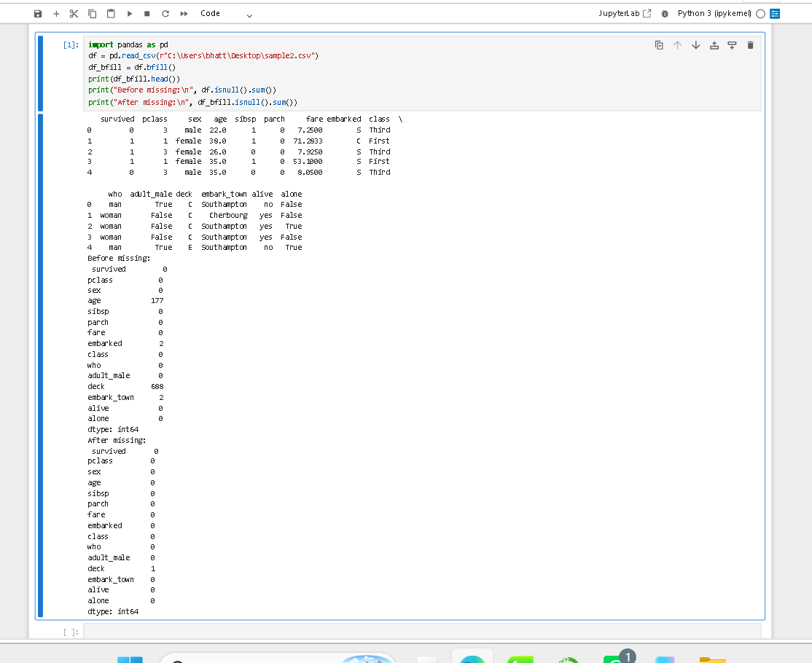
10. Compare the dataset before and after handling missing values.
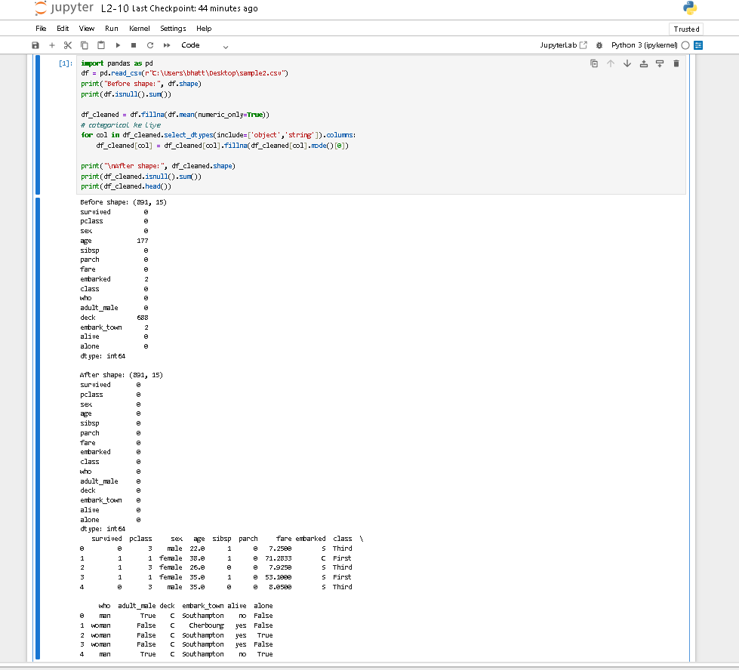
11. Detect outliers using the Interquartile Range (IQR) method.
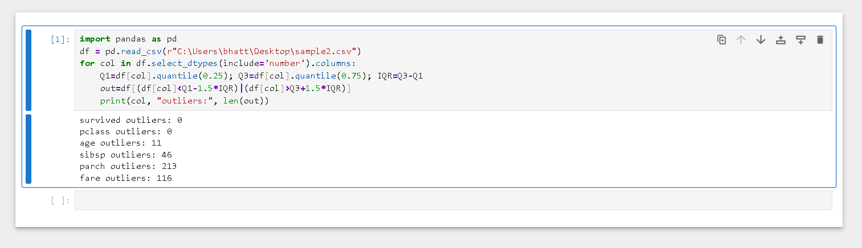
12. Detect outliers using the Z-score method.
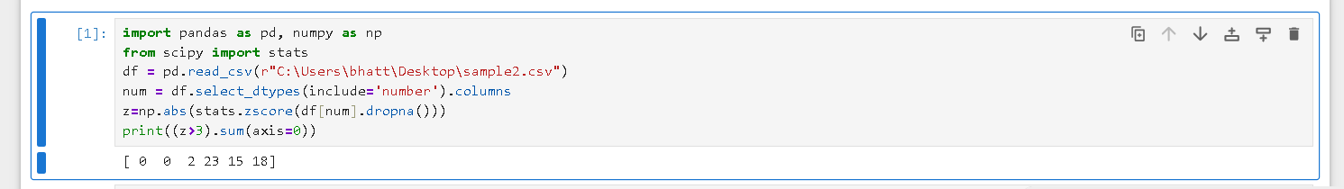
13. Visualize outliers using a Box Plot.
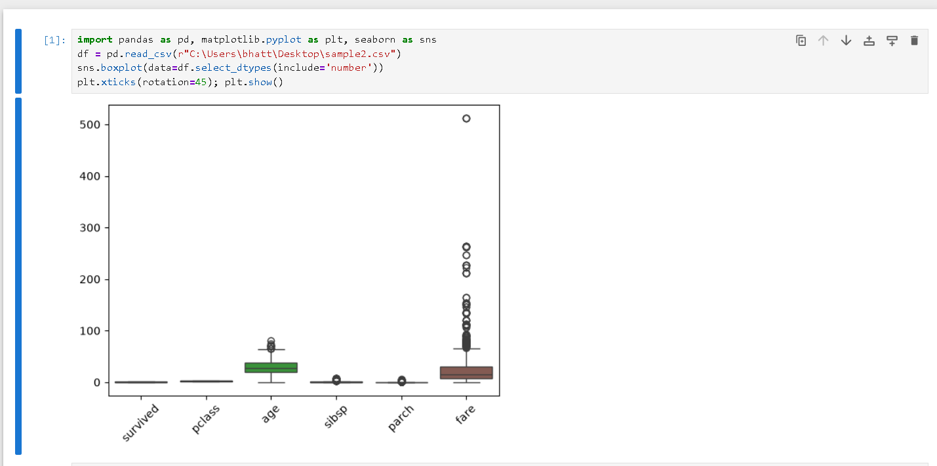
14. Visualize outliers using a Scatter Plot.
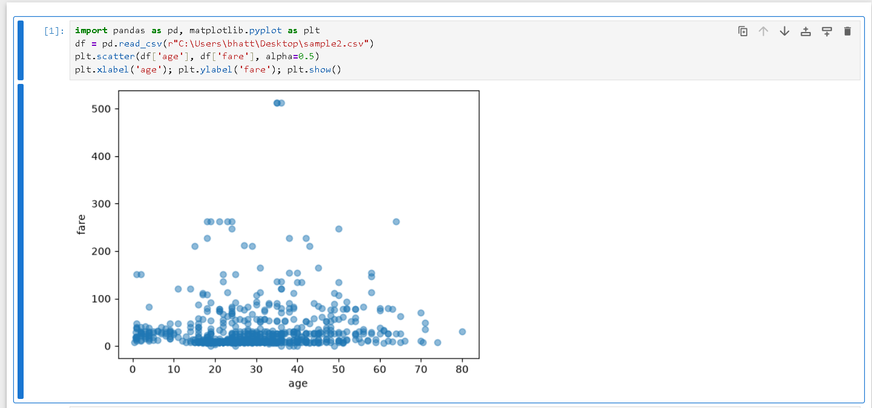
15. Remove outliers using the IQR method.
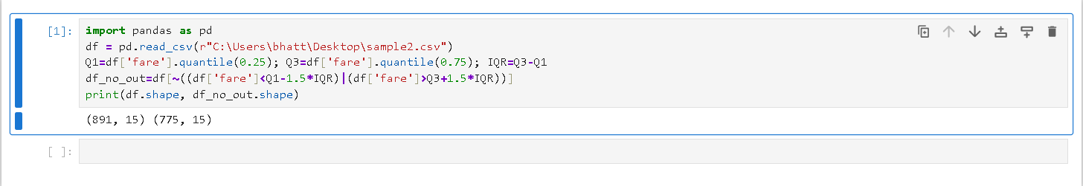
16. Replace outliers with the median value.
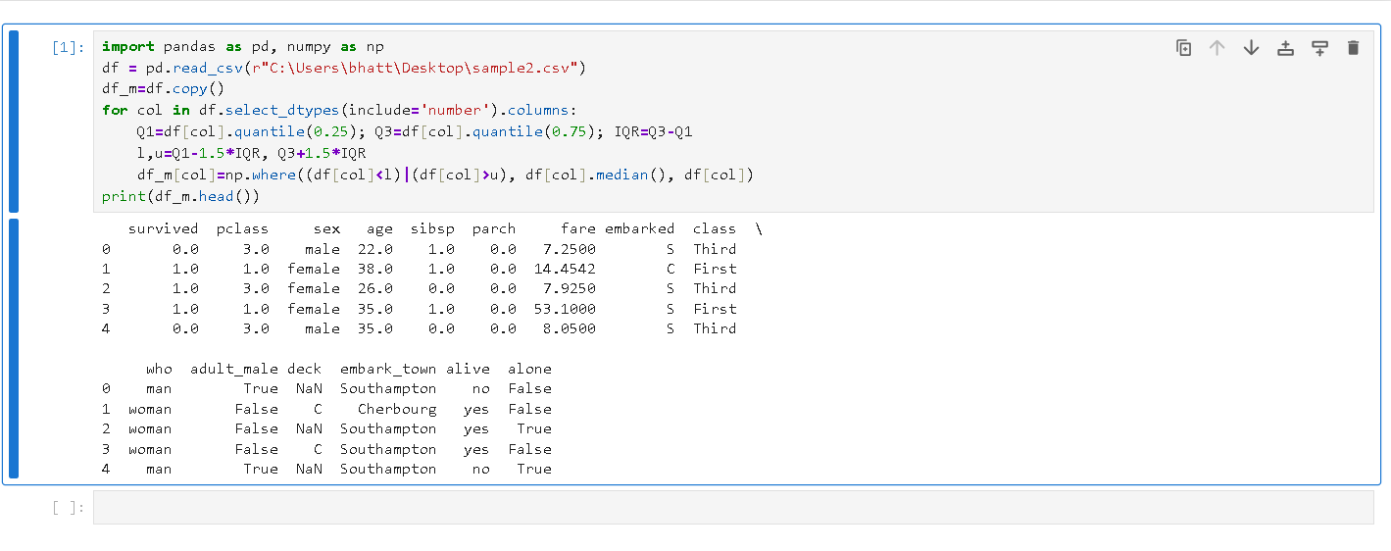
17. Cap outliers using percentile-based capping.
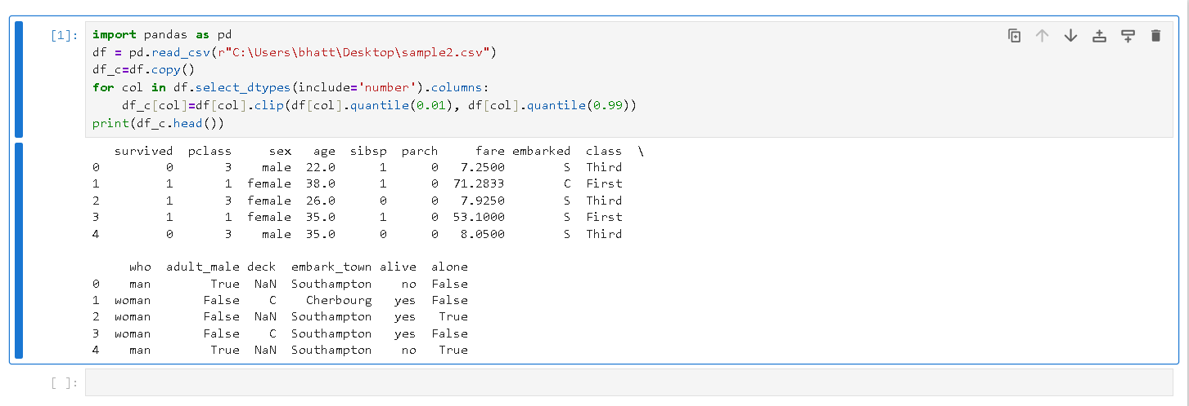
18. Compare the dataset before and after outlier treatment.
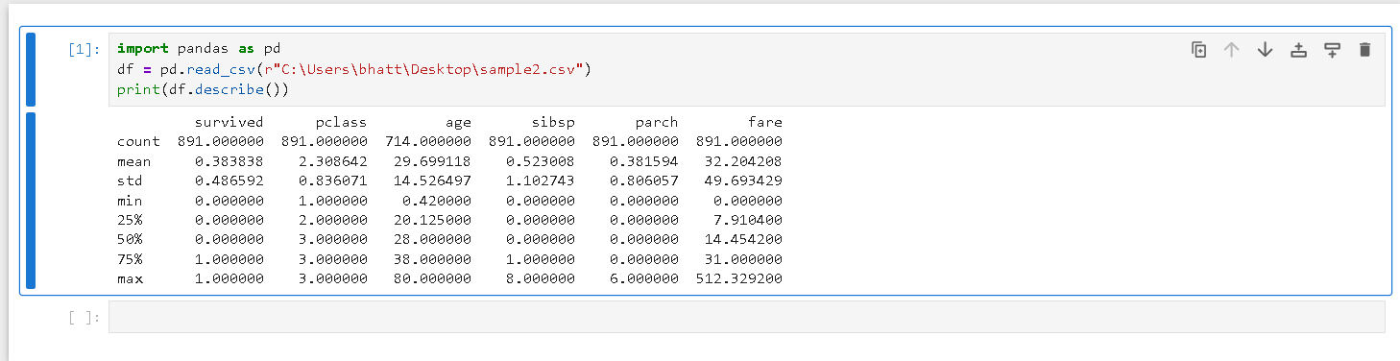
19. Apply Min-Max Normalization to numerical features.
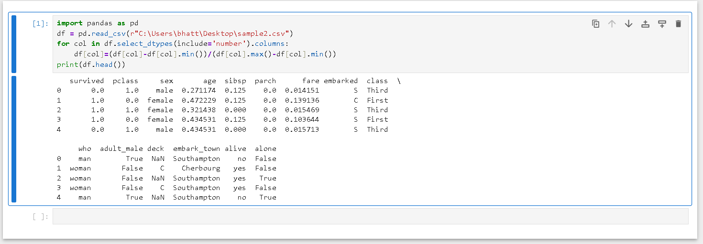
20. Apply Standardization (Z-score Scaling).
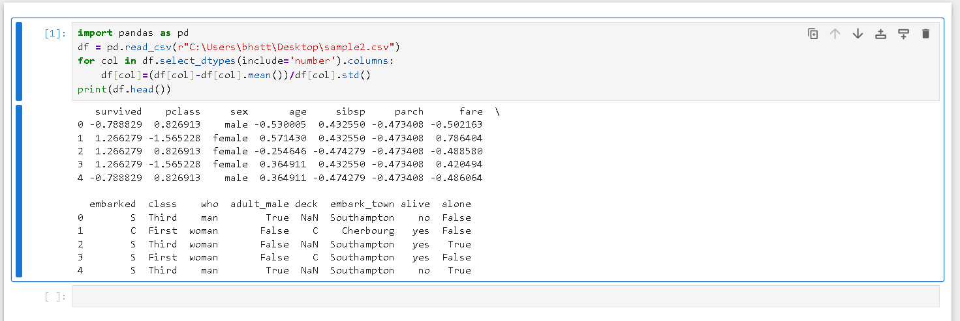
21. Apply Robust Scaling to handle outliers.
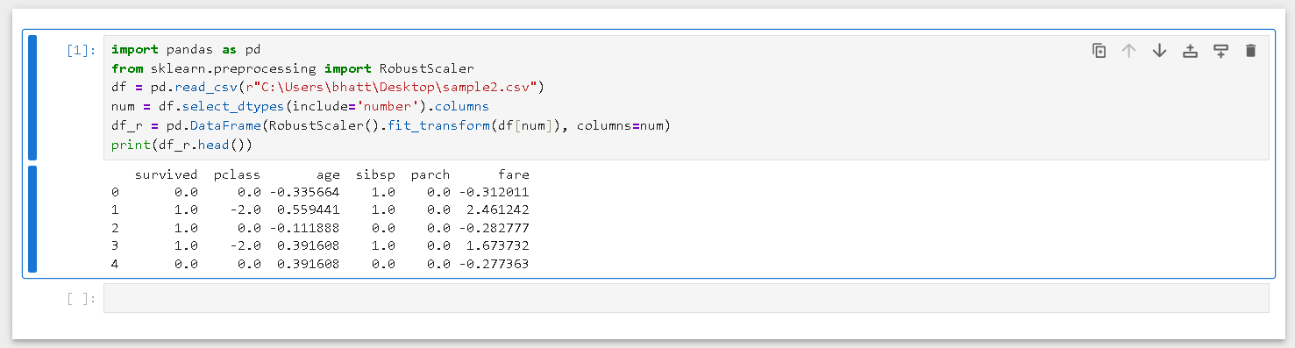
22. Apply Max Absolute Scaling.
23. Compare original and normalized datasets.
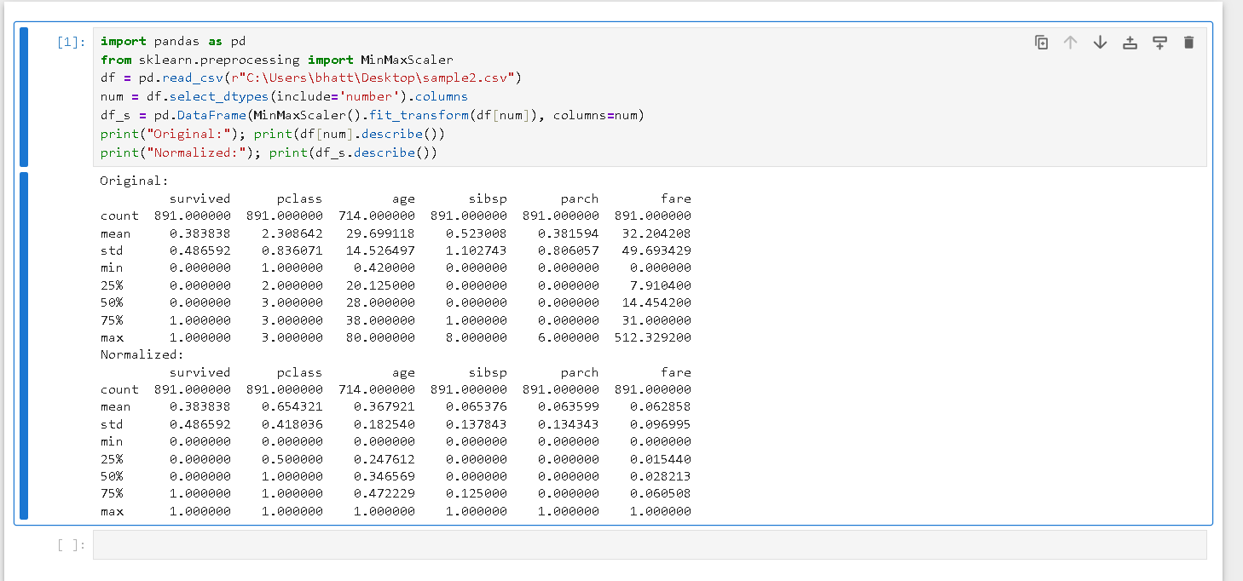
24. Visualize the effect of normalization using histograms.
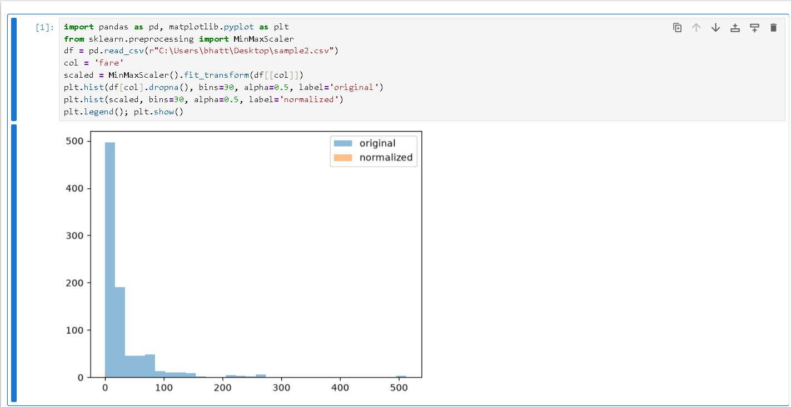
25. Visualize the effect of scaling using box plots.
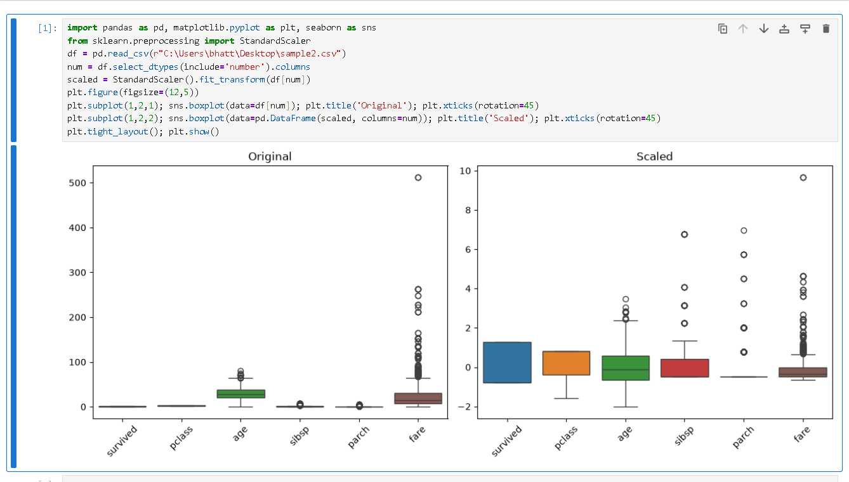
26. Compare different scaling techniques on the same dataset.
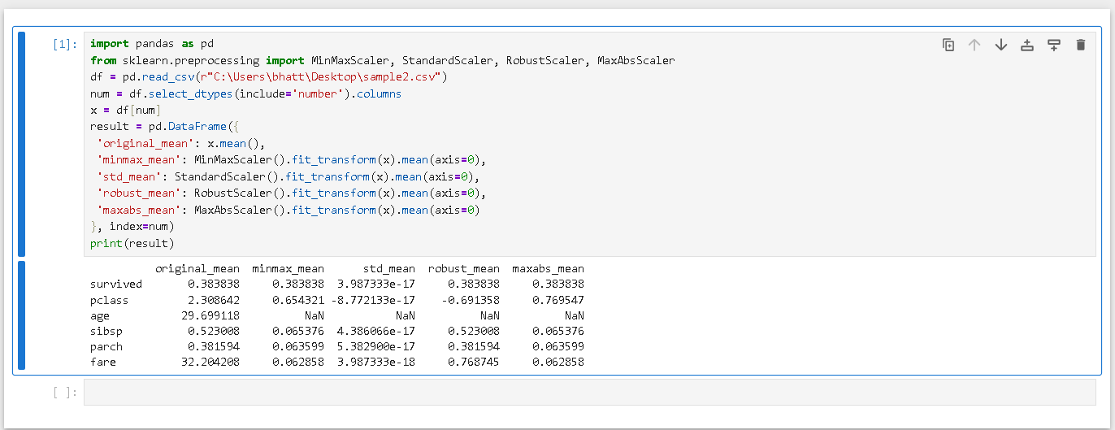
27. Encode categorical variables using Label Encoding.
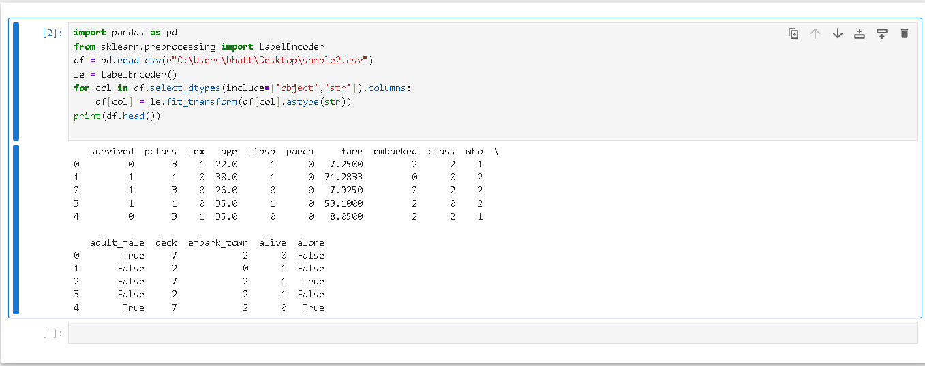
28. Encode categorical variables using One-Hot Encoding.
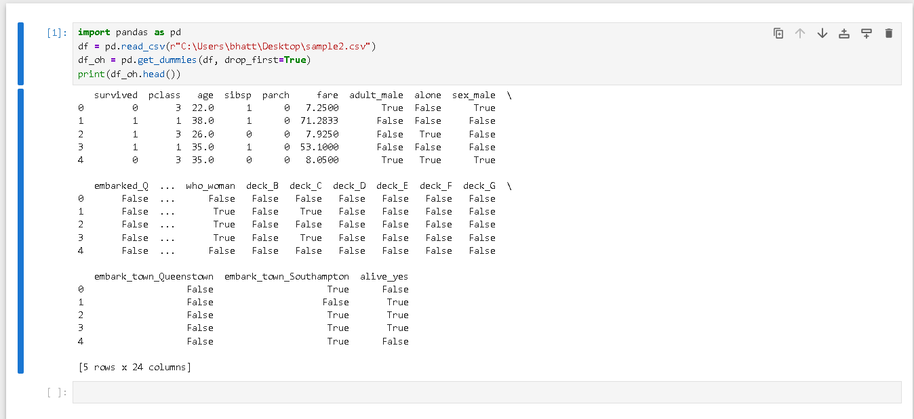
29. Perform Binary Encoding on categorical data.
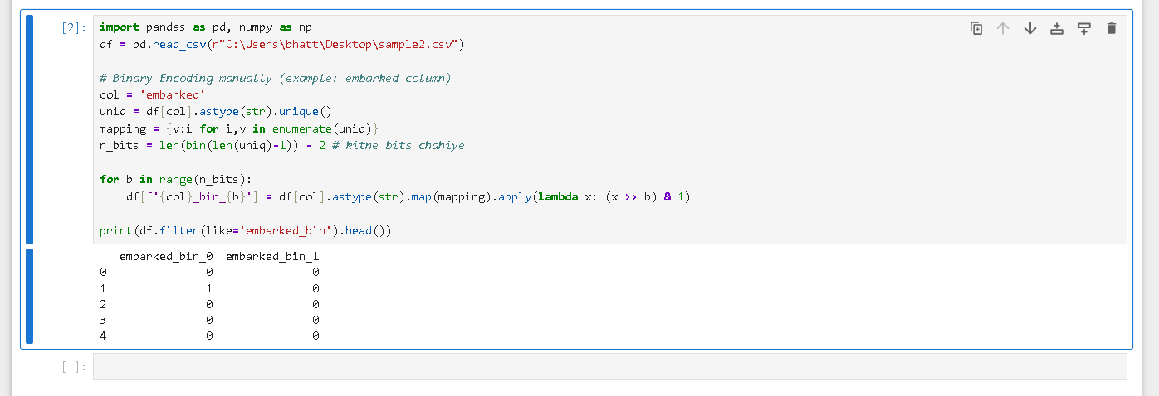
30. Create a new feature by combining two existing columns.
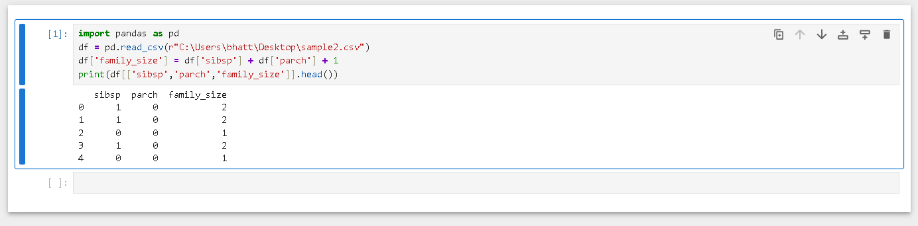
31. Extract year, month, and day from a date column.
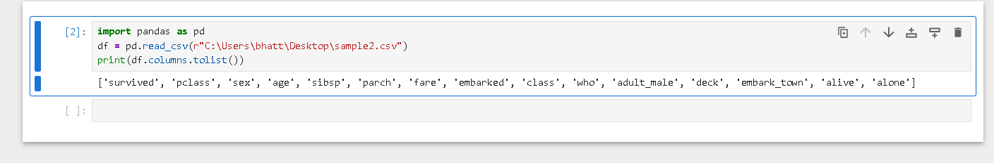
32. Create a new feature using mathematical transformations.
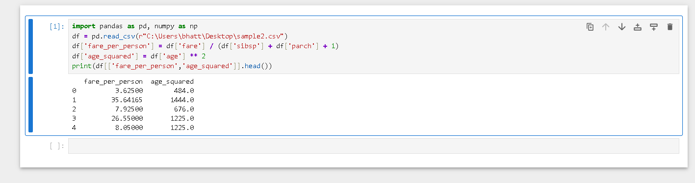
33. Apply Log Transformation to skewed data.
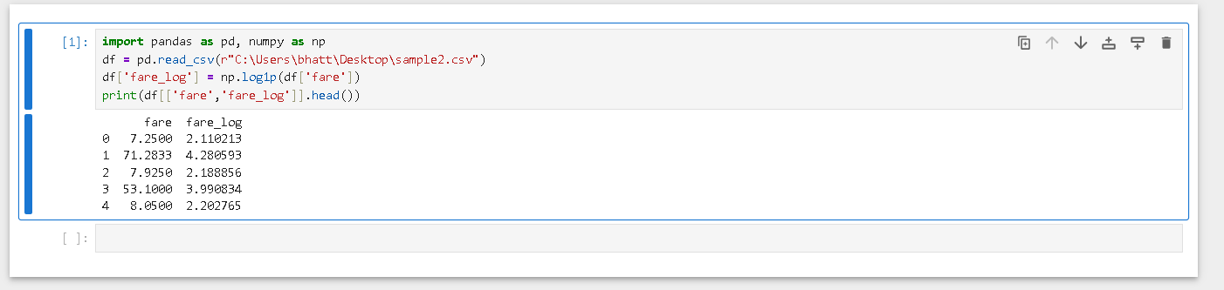
34. Perform Feature Selection using correlation analysis.
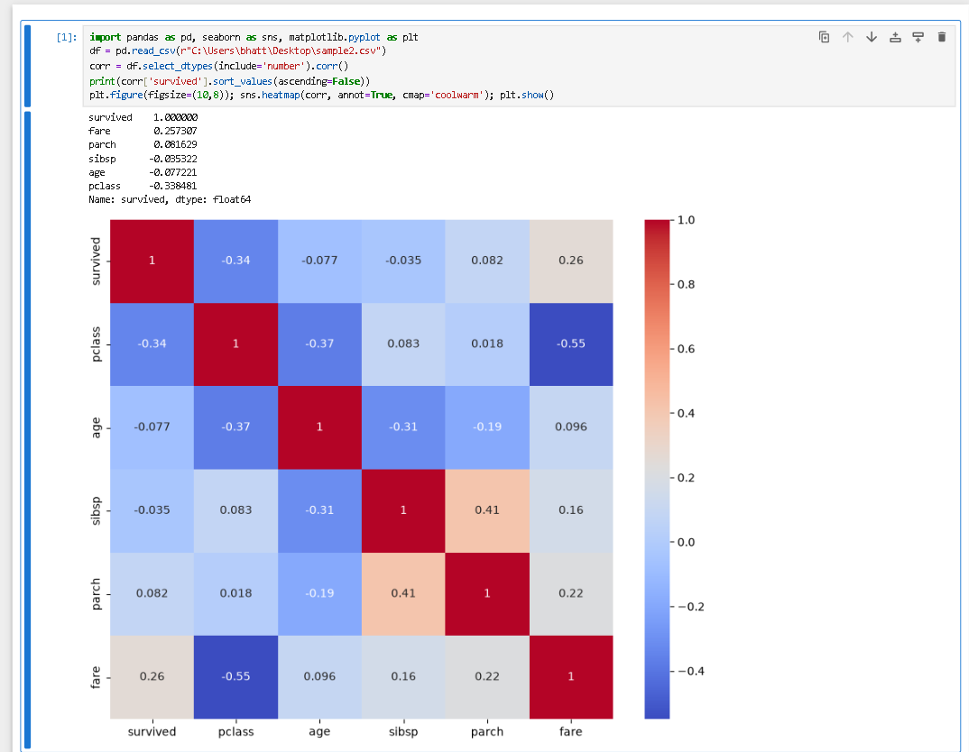
35. Create a final pre-processed dataset ready for Machine Learning.

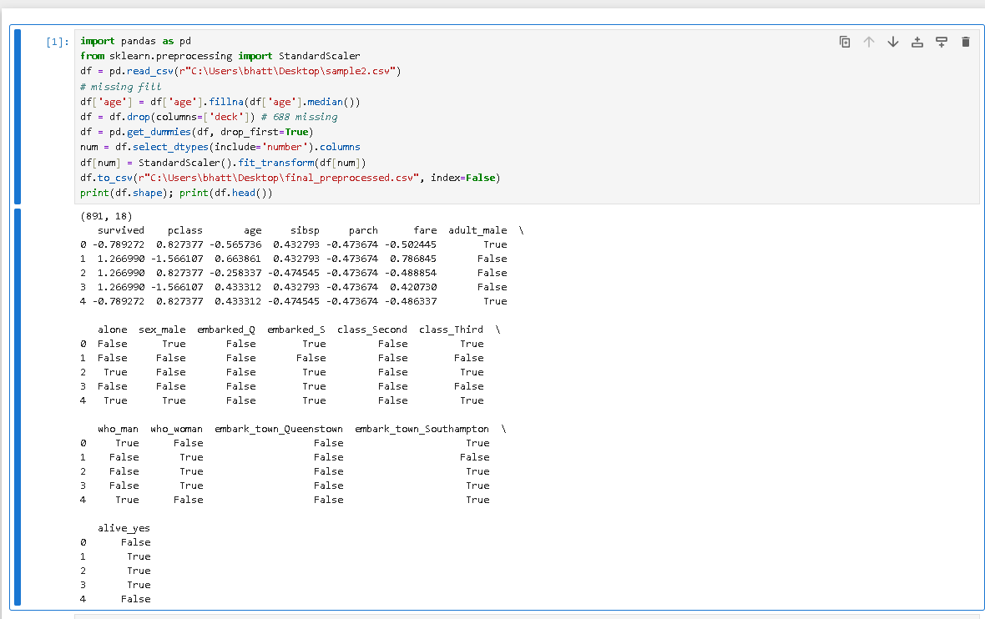
Source code files- https://drive.google.com/drive/folders/1gJPQHDNP_dJcd6aEs-8vgc45dgRMqI63?usp=drive_link

